SofTest Workaround for Windows 10 Creators OS

Note: We currently do NOT support the Windows 10 Creators operating system. This OS does not meet our minimum system requirements at this time.
In order to utilize SofTest on a machine that is running Windows 10 Creators, you must make some changes within the properties of the application. Below are the steps for the available workaround:
1. Right click on the application shortcut from the desktop or from the application icon at C:\Program Files (x86)\Examsoft\Softest 11.0
2. Select Properties from the menu
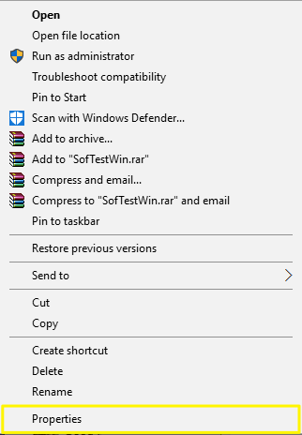
3. Click on the Compatibility tab
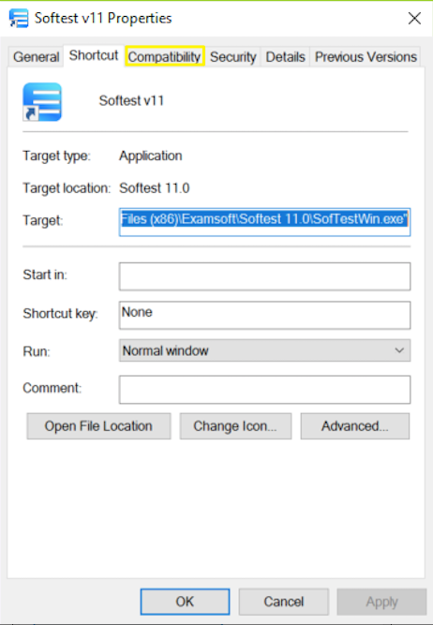
4. Under Compatibility mode, check the box that says "Run this program in compatibility mode for:" and select Windows 8 from the drop down
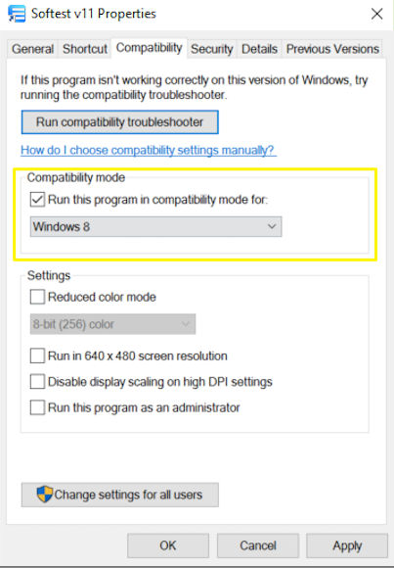
- Click Apply, then OK
One the above steps are completed, exam takers should be able to run SofTest, but keep in mind this operating system is not currently supported. Please contact the Support team if you have any questions.

